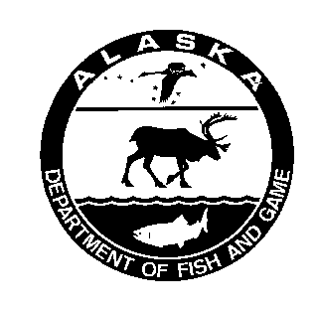 | ALASKA DEPARTMENT OF  FISH AND GAME  DIVISION OF SPORT FISH  MEMORANDUM

TO: | Jim Hasbrouck | DATE: | April 5, 2006
 | Regional Research Supervisor
 | Division of Sport Fish
 | Anchorage
FROM: | Pat Hansen | SUBJECT: | Approval of the Operational Plan Entitled "Upper Cook Inlet salmon personal use harvest monitoring ".
 | Biometrician
 | Research and Technical Services
Haz, I've reviewed the operational plan and approved it.
I do have one concern about the permit. In redesigning the permit we sought the advice of Bill Romberg who we consider the closest person to a survey expert we have within the Department. Bill made 2 suggestions to improve the permit:
- Use check boxes to identify the fishery instead of circling the fishery (circling was used on the 2005 permits)
- Give an example. Bill said that most people won’t read instructions but they will follow an example. He suggested that the permit follow a similar format to the SWHS where the first line is an example.
His first recommendation was incorporated in the 2006 permit but his second recommendation was ignored. I think this was a mistake. If we consider Bill our expert I don’t think his advice should be disregarded.
Bob showed me the permit before it went to the printer and I expressed my concern about ignoring Bill’s suggestion to both you and Bob at that time but no change was made to the permit.
The signed cover sheet is in your box.
cc (via email): Allen Bingham

